Supplementary Materials
Tables

Author & Year | Species | Trophic Level / Age Class | Direction of Movement | Hypothesized Driver | Time Scale
Brönmark et al. 2008 | Roach (Rutilus rutilus) | Primary consumer; Adult | Directional (lake→stream for overwintering, return to lake in spring) | Predator avoidance (reducing growth:predation trade-off in lake in winter) | Seasonal
Swanson et al. 2021 | White sucker (Catostomus commersonii); longnose sucker (Catostomus catostomus) | Secondary consumer; Adult | Directional (lake→stream for spawning, return to lake) | Reproduction (spawning); cued by water temperature, discharge, and time of day | Seasonal
Magnuson et al. 1985 | Multiple cyprinids and percids (8 species) | Primary–secondary consumer; YOY (and adult, treated separately) | Directional (lake→stream in fall/winter; stream→lake in spring) for YOY; within-lake vertical movements for adults | Hypoxia avoidance (winterkill avoidance); cued by ice formation or darkness (not oxygen stress itself) | Seasonal
Hahlbeck et al. 2022 | Redband rainbow trout (Oncorhynchus mykiss newberrii) | Tertiary consumer; Adult | Bidirectional (biannual: tributary↔lake) | Thermal refuge (summer) + foraging (spring/fall) + reproduction (winter spawning) | Seasonal (biannual cycle)
Colborne et al. 2019 | Lake sturgeon (Acipenser fulvescens) | Secondary consumer; Adult | Bidirectional (river↔lake; 5 distinct individual patterns) | Multiple: reproduction (spawning), foraging, and overwintering refuge; high individual variation | Seasonal
Jones et al. 2016 | Longnose sucker (Catostomus catostomus); white sucker (Catostomus commersonii) | Secondary consumer; Adult | Directional (lake→stream for spawning, return to lake) | Reproduction (spawning); nutrient subsidy transfer from lake to oligotrophic stream | Seasonal
He & Kitchell 1990 | Multiple small-bodied cyprinids (6+ species); northern pike (Esox lucius) as experimental predator | Primary consumer; Mixed (adults and juveniles) | Directional (lake→stream ; predation-driven emigration) | Predation avoidance (experimental); also hypoxia avoidance (seasonal) | Exiting the lake once to avoid predators; potential seasonal movements out of lake to avoid hypoxia
Curry et al. 1997 | Brook trout (Salvelinus fontinalis) | Secondary consumer; Juvenile (YOY / age-0) | Directional (lake→stream during warmer periods, return to lake in cooler periods) | Thermal refuge (lake littoral temperatures approach lethal levels for YOY in summer; streams cold via groundwater) | Seasonal
Campbell et al. 2019 | Lahontan cutthroat trout (Oncorhynchus clarkii henshawi) | Tertiary consumer; age-0 and age-1+ juveniles | Directional (stream→lake for juveniles during spawning period of adults) | Seeking refuge from spawning adults and foraging opportunities in alternate lake habitat | Seasonal
Dolinsek et al. 2014 | 37 species (diverse community; Lake Ontario tributaries) | Primary–tertiary consumer; All age classes (adults and juveniles) | Bidirectional (lake↔stream) | Multiple: reproduction, foraging, predation refuge; not exclusively spawning — includes partial migration and non-reproductive habitat use | Seasonal and intra-seasonal
Bentley et al. 2015 | Arctic grayling (Thymallus arcticus); rainbow trout (Oncorhynchus mykiss) | Secondary consumer; Sub-adult | Bidirectional (inter-tributary movements using lake as corridor) | Foraging (prospecting for productive feeding patches; positioning for salmon subsidy) | Intra-seasonal
Kikko et al. 2024 | Honmoroko (Gnathopogon caerulescens) | Primary consumer (planktivore); All age classes (juvenile through adult) | Directional (main lake to lagoons for spawning, with tributaries as corridors) | Reproduction (natal homing to spawning lagoon); foraging (availability of zooplankton prey) | Seasonal
Lindsey & Northcote 1963 | Redside shiner (Richardsonius balteatus) | Primary–secondary consumer; Adult and larvae/fry (treated separately) | Directional (lake→stream for spawning; fry passively downstream stream→lake) | Reproduction (spawning; triggered by temperature >10°C); passive fry displacement away from ephemeral stream habitat | Seasonal

Season | Location | n | Lake Carbon (mean ± SE) | Trophic Position (mean ± SE)
Spring | Creek | 77 | 0.493 ± 0.022 | 3.026 ± 0.024
Spring | Lake | 49 | 0.582 ± 0.025 | 2.975 ± 0.026
Summer | Creek | 35 | 0.335 ± 0.026 | 3.113 ± 0.031
Summer | Lake | 3 | 0.895 ± 0.071 | 2.55 ± 0.126
Fall | Creek | 61 | 0.479 ± 0.027 | 3.052 ± 0.031
Fall | Lake | 21 | 0.851 ± 0.042 | 2.74 ± 0.054

Season | Location | n | Lake Residency (mean ± SE) | Recurrence (mean ± SE)
Spring | Creek | 12 | 0.665 ± 0.107 | 11.33 ± 8.24
Spring | Lake | 4 | 0.783 ± 0.182 | 6.25 ± 1.31
Summer | Creek | 21 | 0.611 ± 0.104 | 1.14 ± 0.4
Summer | Lake | 7 | 0.967 ± 0.033 | 0.14 ± 0.14
Fall | Creek | 11 | 0.69 ± 0.081 | 8.82 ± 2.37
Fall | Lake | 4 | 0.754 ± 0.151 | 1.75 ± 1.44

Figures
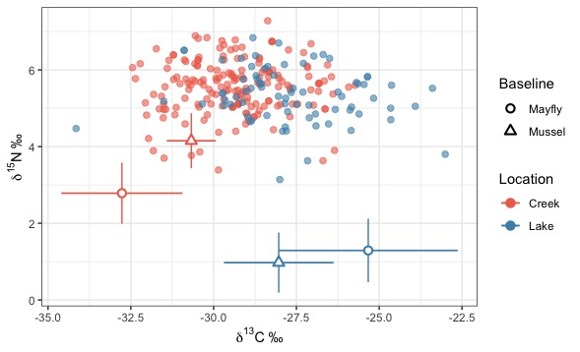

Figure S1. Biplot of δ¹³C and δ¹⁵N stable isotope values from shiner liver tissue (n = 252). Each point represents an individual shiner liver sample, coloured by the location in which the fish was captured (lake = blue, creek = pink). Baseline values are shown as mean ± SD for mayflies and mussels collected in each habitat across the study period.

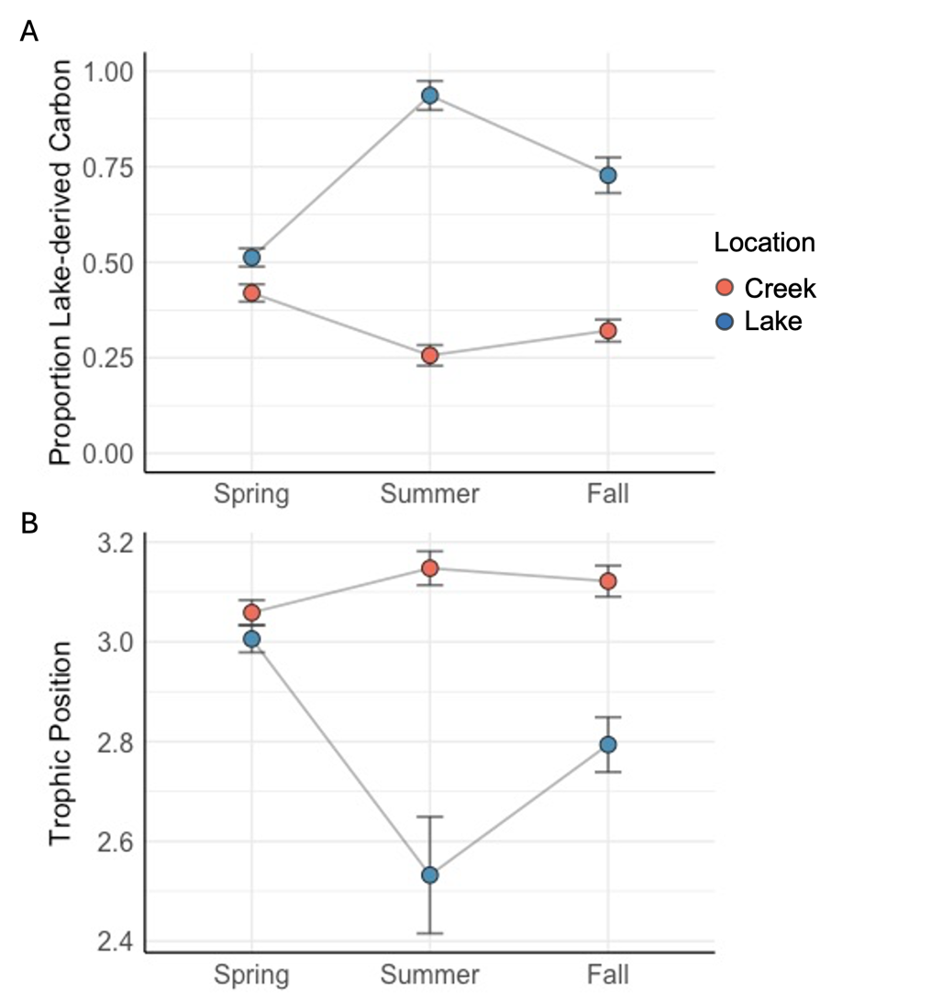

Figure S2. Mean (±SE) proportion of lake-derived carbon (A) and trophic position (B) of fish captured in the creek (pink) and lake (blue) across seasons calculated from non-lipid corrected stable isotope data.
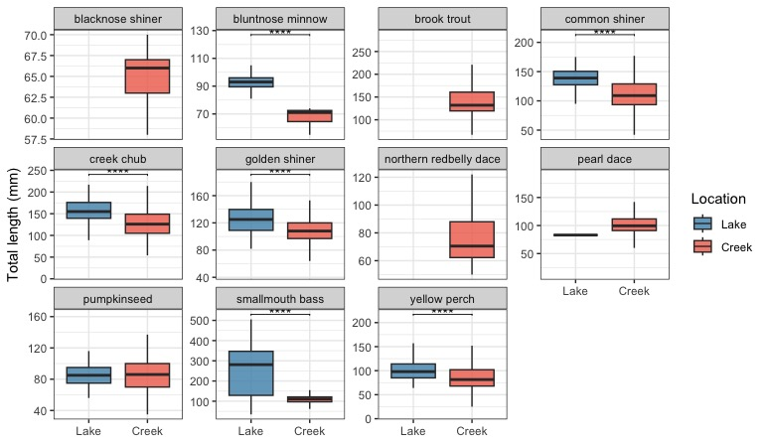

Figure S3. Boxplots of total length (mm) for fish species captured in lake (blue) and creek (pink) habitats during seasonal netting surveys and angling across the study period. Each panel shows a different species. Asterisks denote significant differences in total length between habitats (*p < 0.05, **p < 0.01, ***p < 0.001, ****p < 0.0001).

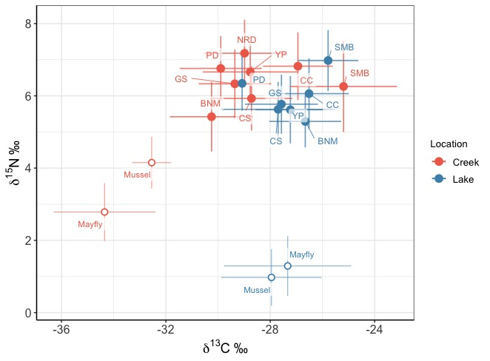

Figure S4. Biplot of mean (± SD) δ¹³C and δ¹⁵N stable isotope values from liver tissues of fish species captured in lake (orange) and creek (blue) habitats. Points represent species means, labelled with species abbreviations (BNM = bluntnose minnow, CC = creek chub, CS = common shiner, GS = golden shiner, NRD = northern redbelly dace, PD = pearl dace, SMB = smallmouth bass, YP = yellow perch). Baseline values are shown for mayflies and mussels collected in each habitat.

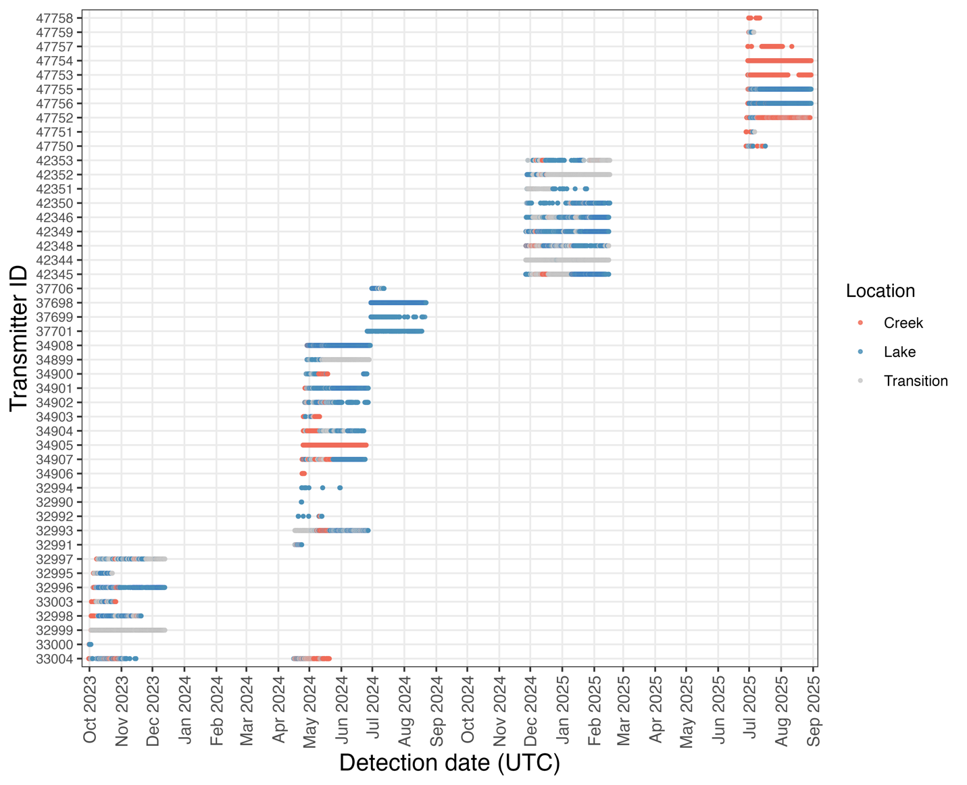
Figure S5. Abacus plot of acoustic telemetry detections for tagged golden shiners from October 2023 to September 2025. Each row represents an individual fish (identified by transmitter ID), with points showing detections over time. Colours indicate the location (habitat) the fish was in at the time of detection (creek = pink, lake = blue, transition = grey).
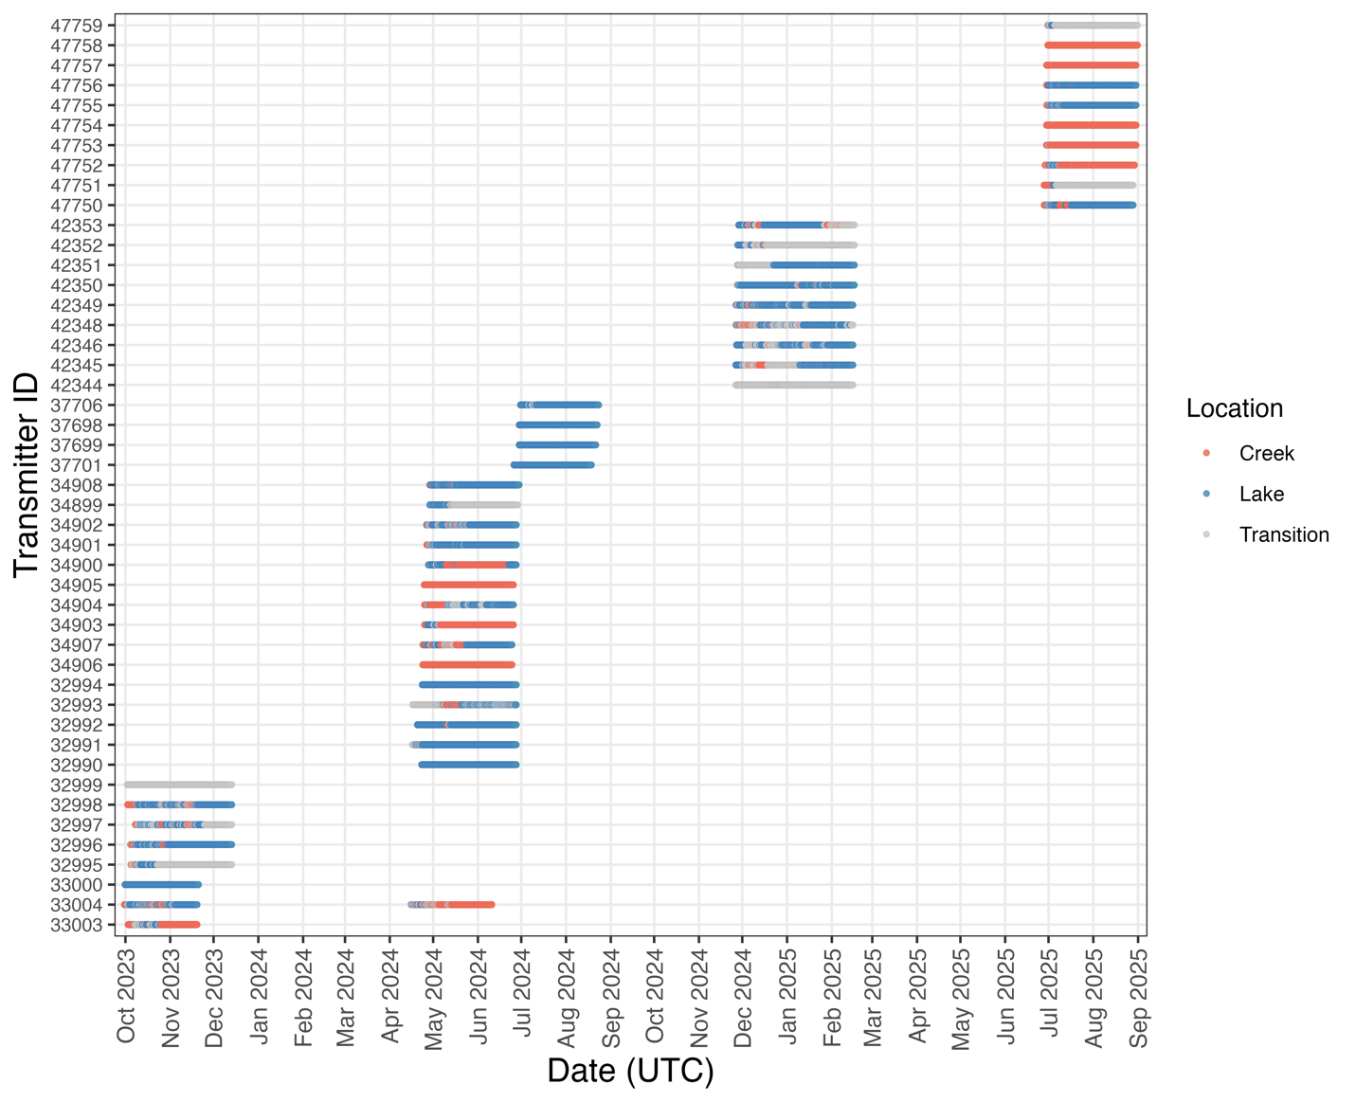
Figure S6. Abacus plot of enriched acoustic telemetry dataset for tagged shiners from October 2023 to September 2025. Each row represents an individual fish (identified by transmitter ID), with horizontal bars showing continuous periods where the last known location was carried forward in the absence of detections within a given minute. Colours indicate the location (habitat) the fish was in at the time of detection (creek = pink, lake = blue, transition = grey).

